Home / Introduction Page Hello, my name is Maeann A. Olitres.

I am a third-year Bachelor of Science in Information Technology (BSIT) student at Davao del Sur State College. I am deeply passionate about graphic design and continuously strive to enhance my creative and technical skills in this field. With a strong foundation in IT and a keen eye for visual aesthetics, I aim to combine technology and design to create engaging and effective digital experiences.*______________________________________* 📄**Resume / CV Name:** Mae Ann A. Olitres **Address:** Highway Loay Zone II Santa Cruz Davao Del Sur Birthdate: October 19,2003 Email: olitresmaeann19@gmail.com

<https://www.facebook.com/mae.ann.olitres.2024>

**PROFILE** : Innovative and highly skilled Graphic Designer with 3years of experience in branding, digital content creation, and visual communication. Expertise in Adobe Creative Suite, UI/UX design, and motion graphics. Adept at translating complex ideas into compelling visual narratives that enhance brand identity and engagement. Proven ability to manage multiple projects and collaborate with cross-functional teams to deliver high-quality designs that drive business success.

**WORKEXPERIENCE:**

*Executive Staff /Marketing JMDV GARMENTS Aurora 6th Digos City*

2022-2023

*Freelancer Upwork*

2023-2024

*Designer /Lllama Company Remotask*

2023-2024

**EDUCATIONAL BACKGROUND:**

Santa Cruz Central Elementary School

2013-2016

Santa Cruz National High School

2016-2017

Present -Bachelor of Science in Information Technology

2024

**SKILLS:**

* Graphic Design Tools: Adobe Photoshop, Illustrator, InDesign, Figma, Canva
* Branding & Marketing: Logo Design, Brand Identity, Social Media Graphics
* Motion Graphics & Video Editing: Adobe After Effects, Premiere Pro

**LANGUAGE :**

* English (Fluent)
* Filipino
* Bisaya

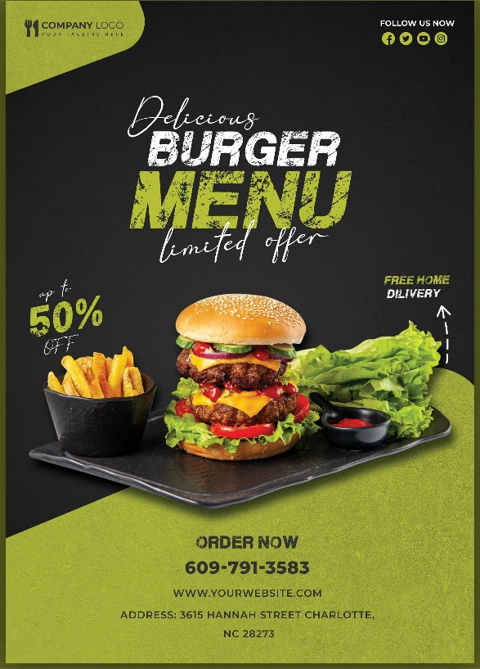**PROJECTS:**

